Interaction in the Public
Aesthetics, Social Acceptability, and Social Context

Case Sheet
We ask all participants to briefly describe a technology they frequently use or which they work on. The technology should have a social use context, which means to us that some other people are present - strangers, colleagues, or family members (or any other people).

Please fill out the boxes below and attach this file to your email, together with the application form. We will use these cases during the workshop in an interactive session.

General Information |  | Picture
Name: | Segway | 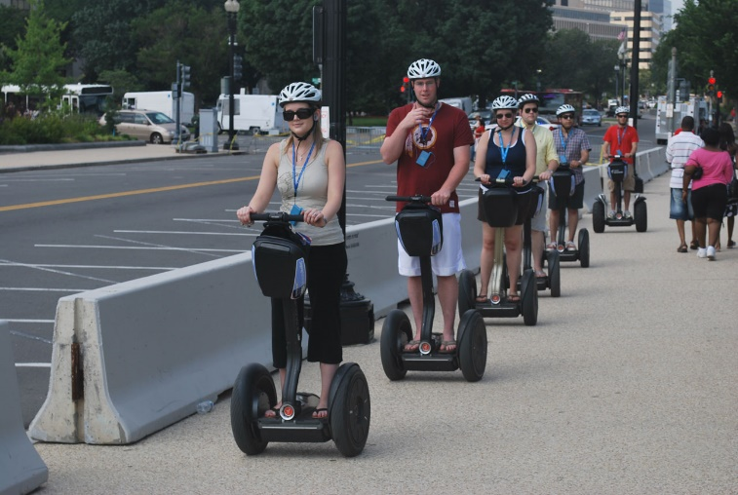
User Group(s): | Tourists, trade fair visitors
Use Context: | Public spaces, sidewalks, exposition centers. Mostly outside in cities, alone or in groups
The “Segway” example is meant to illustrate how such a sheet could look like. You can use photos or drawings or any other picture you consider appropriate. The technology can be anything from a smartphone navigation app for runners, a headset, electric wheelchairs, surgeon tools, … the only requirement is that it should be used in contexts with other people present.

Description
Please provide some more details here. For example, what is the purpose of the technology? How many people use it? Which activities can the users perform with this technology?
The Segway is used by tourists for individual mobility. It helps them move around a city without getting too tired. The users are in control of where they want to go. One Segway is used by one person, but often tourist groups use several Segways in a “flock” when driving around a city. The Segways don’t protect from rain or snow, so people usually use them mostly when the weather is good.

